



INSTITUTE FOR ADVANCED COMPUTING AND SOFTWARE DEVELOPMENT AKURDI, PUNE

Documentation On

“TickItNow”

(Online Movie Ticket

Booking System)

PG-DAC MAR 2024

**Submitted By:**

**Group No: 27**

**Roll No. Name:**

**243050 M.Faraz Patwegar**

**243107 Utkarsha Chinde**

**Mr. Harshal Waghchaure Mr. Rohit Puranik**

Project Guid Center Coordinator

# ABSTRACT

The Movie Ticket Booking System project is a digital solution designed to redefine the way movie enthusiasts book tickets, enhancing convenience and efficiency in the entertainment industry. In an era characterized by digital transformation, this project seeks to streamline the ticket booking process for customers and optimize theater management for administrators.

The project's main objectives are to provide a user-friendly platform for moviegoers to browse movie options, select showtimes, choose seats, make secure payments, and receive electronic tickets. Additionally, the project aims to automate various aspects of theater management, making the process smoother for theater staff.

At the heart of the project lies a comprehensive online platform, seamlessly integrating frontend and backend components. The frontend enables customers to interact with the system intuitively, while the backend handles business logic, data management, and communication between various parts of the system.

Key features of the Movie Ticket Booking System include user registration and login, real-time movie listings and showtimes, interactive seat selection, secure payment integration, instant booking confirmations, and personalized user profiles. An admin dashboard empowers theater staff to efficiently manage movies, showtimes, seats, and access valuable booking reports.

The backend, built using the Spring Boot framework, serves as the backbone of the application, ensuring seamless communication between the frontend and the database. It handles user authentication, business logic implementation, database interactions, security enforcement, and error handling. The utilization of Spring Boot simplifies development, accelerates integration, and ensures data integrity.

The project encountered challenges, such as payment gateway integration and seat availability synchronization, which were successfully overcome through strategic problem-solving and collaboration.

Looking towards the future, the project envisions enhancements such as the development of a dedicated mobile app, AI-driven movie recommendations, and integration with social media platforms. These advancements aim to further improve user engagement, accessibility, and customer satisfaction.

In conclusion, the Movie Ticket Booking System project showcases the fusion of modern technology and entertainment, presenting a solution that benefits both customers and theaters. Through seamless interaction, secure transactions, and efficient management, the project exemplifies the power of digital innovation in simplifying and enhancing the movie-going experience.

# ACKNOWLEDGEMENT

I take this occasion to thank God, almighty for blessing us with his grace and taking our endeavor to a successful culmination. I extend my sincere and heartfelt thanks to our esteemed guide,

**Mr. Harshal Waghchaure** for providing me with the right guidance and advice at the crucial juncture sand for showing me the right way. I extend my sincere thanks to our respected **Centre Co-Ordinator**

**Mr. Rohit Puranik**, for allowing us to use the facilities available. I would like to thank the other faculty members also, at this occasion. Last but not the least, I would like to thank my friends and family for the support and encouragement they have given me during the course of our work.

M.Faraz Patwegar (240341220104)

Utkarsha Chinde (240341220208)

# TABLE OF CONTENTS

## 

|  |  |  |
| --- | --- | --- |
| Sr. No | Description | Page No. |
| 1 | Introduction | 1 |
| 2 | SRS | 4 |
| 3 | Software and Hardware requirements | 7 |
| 4 | Database Design | 8 |
| 5 | ER Diagram | 13 |
| 6 | Use Case Diagram | 14 |
| 7 | UML Diagrams | 15 |
| 8 | Data Flow Diagram | 16 |
| 9 | Activity Diagram | 17 |
| 10 | Class Diagram | 18 |
| 11 | Sequence Diagram | 19 |
| 12 | Snapshots | 20 |
| 13 | Future Scope | 29 |
| 14 | References | 30 |
| 15 | Conclusion | 31 |

# INTRODUCTION

In the contemporary digital landscape, technology continues to reshape traditional industries, providing innovative solutions that enhance convenience and efficiency. The Movie Ticket Booking System project represents a dynamic amalgamation of technology and entertainment, aiming to revolutionize the way movie enthusiasts engage with the cinematic experience.

The project is driven by the recognition of the evolving expectations of modern audiences and the opportunities presented by digital advancements. As online platforms become integral to daily life, the movie ticket booking process demands a transformation that aligns with the pace and convenience users have come to expect. The project seeks to bridge this gap by creating a seamless and user-friendly digital ecosystem for moviegoers and theater administrators alike.

The essence of the Movie Ticket Booking System project lies in its dual purpose: to simplify the movie ticket booking journey for customers while enhancing the operational efficiency for theaters. By providing a comprehensive platform that integrates real-time movie listings, interactive seat selection, secure payment, and instant e-ticket issuance, the project reimagines the way movie tickets are accessed and purchased.

In addition to elevating the user experience, the project recognizes the significance of efficient theater management. An admin dashboard empowers theater staff to effortlessly manage movie schedules, seat availability, and customer interactions. The result is a streamlined and organized workflow that maximizes theater revenue and customer satisfaction.

As we delve into the intricacies of the Movie Ticket Booking System project, we will explore its components, architecture, features, challenges encountered during its development, and the strategic solutions that were employed. Furthermore, we will glimpse into the future, envisioning potential enhancements that will further enrich the experience for both users and theaters.

In a world where digital solutions are increasingly shaping our interactions and experiences, the Movie Ticket Booking System project stands as a testament to the marriage of technology and entertainment. By modernizing the way movie tickets are booked, this project not only reflects the evolution of an industry but also sets the stage for a more convenient and engaging cinematic journey.

* 1. **PROJECT OBJECTIVE**

The objectives of the Movie Ticket Booking System project are rooted in enhancing the moviegoing experience for customers and optimizing operational efficiency for theaters. This section delves into the specific details of each objective, highlighting their significance and the anticipated outcomes.

**1. Streamline the Ticket Booking Process:**

The primary objective of the project is to simplify and expedite the process of booking movie tickets. Traditional methods often involve long queues and manual ticket issuance, leading to inconvenience and time wastage for customers. By creating an intuitive and user-friendly online platform, we aim to eliminate these bottlenecks. Customers will be able to effortlessly browse movie listings, select preferred showtimes, choose seats, and complete transactions, all from the comfort of their devices. This streamlined process will significantly reduce the time required for booking tickets, ultimately enhancing customer satisfaction and encouraging higher ticket sales.

**2. Automation for Theater Staff:**

The project recognizes the administrative challenges faced by theater staff in managing ticket sales, seat allocations, and showtime scheduling. By automating these processes, the system seeks to relieve theater administrators from manual tasks, allowing them to focus on delivering an exceptional movie experience. Automated seat allocation will prevent overbooking and ensure a smooth ticketing process. Moreover, automated showtime scheduling will optimize resource allocation, reducing human error and enhancing overall operational efficiency.

**3. Enhance User Experience:**

User experience is paramount in today's digital age. The project aims to create an engaging and user-centric platform that caters to the preferences of moviegoers. The interactive seat selection feature provides customers with the freedom to choose their preferred seats, view seat availability in real time, and ensure an enjoyable viewing experience. Immediate booking confirmations and electronic ticket delivery contribute to a seamless and hassle-free process. Furthermore, personalized user profiles allow customers to save their preferences and simplify future bookings, resulting in a more user-friendly journey.

**4. Improve Theater Management:**

The project recognizes that efficient theater management is integral to providing a smooth moviegoing experience. The admin dashboard equips theater staff with comprehensive tools to manage movie listings, showtime schedules, seat arrangements, and booking reports. This centralized control allows administrators to make informed decisions, optimize resource allocation, and tailor the theater experience to meet customer demands. The result is improved theater management, reduced operational complexities, and enhanced revenue generation.

In conclusion, the Movie Ticket Booking System project's objectives are interconnected, working towards creating a holistic solution that benefits both customers and theaters. By streamlining the booking process, automating tasks, enhancing user experiences, and improving theater management, the project aims to elevate the moviegoing experience to new heights. Through technological innovation, convenience, and efficiency, the project aspires to set new standards for the way movies are enjoyed and managed in the digital age.

# SYSTEM ANALYSIS

System analysis is the process of gathering and interpreting facts, diagnosing problems, and

using the information to recommend improvements on the system. System analysis is a

problem-solving activity that requires intensive communication between the system users

and system developers.

1.Requirements Gathering:

Begin by understanding the specific requirements of the system. This involves interacting with stakeholders, including users, administrators, and other involved parties. Document their needs, expectations, and any constraints that the system must adhere to.

2.Use Case Analysis:

Identify the primary use cases of the system. These could include user

registration, browsing movies, booking tickets, making payments, viewing showtimes,

managing user profiles, and more. Create use case diagrams to visualize the interactions

between actors and use cases.

3.System Architecture:

Define the high-level architecture of the system. This could include

components like the user interface, application server, database server, payment gateway

integration, external APIs (e.g., for movie data), and any other relevant components. Decide

on the technology stack that will be used.

4.Data Flow Analysis:

Map out the flow of data within the system. Identify how data is collected, processed, stored, and displayed. Create data flow diagrams to illustrate the movement of data between different components.

5.User Interface Analysis:

Evaluate the user interface design for its usability, accessibility, and overall user experience. Consider factors like responsiveness, ease of navigation, clarity of information, and consistency in design elements.

6.Database Design:

Design the database schema to store relevant information such as movie details, user profiles, bookings, payment history, and more. Ensure data integrity, normalization, and proper indexing for efficient querying.

7.Security Analysis:

Identify potential security risks and vulnerabilities in the system. Implement measures to protect user data, prevent unauthorized access, and secure payment transactions. This could involve techniques like authentication, and authorization.

**Problem Statement:**

Problem Analysis:

The basic aim of problem analysis is to obtain clear understanding of the needs of the clients and the users, what exactly is desired from the software, and what the constraints on the solution are. Analysis leads to the actual specification.

Problem Analysis Approaches

There are three basic approaches to problem analysis.

1. Informal Approach.

2. Conceptual modeling-based Approach

3. Prototyping Approach.

In this project we use Conceptual modeling-based Approach to understand the exact requirement of the organization.

Preliminary Evolution:

The preliminary investigation starts as soon as someone either a user or a member of a particular department recognizes a problem or initiates a request, to modify the current computerized system, or to computerize the current manual system. An important outcome of the preliminary investigation is determining whether the system is feasible or not.

from the customers.

* + 1. **SYSTEM OBJECTIVES:**

1.Streamline the ticket booking process for customers.

2.Reduce manual work for theater staff through automation.

3.Enhance the overall user experience.

Improve theater management and reporting capabilities.

**2.3.3.1 NON-FUNCTIONAL REQUIREMENTS**

Non-functional requirements for an Online Ticket Booking System describe the quality attributes and characteristics of the system that go beyond its specific functionalities. These requirements focus on aspects such as performance, security, usability, and other important qualities that contribute to the overall user experience and system reliability. Here are some non-functional requirements for such a system:

**1.Performance:**

The system should provide fast response times for all user interactions (e.g., page loading, seat selection, payment processing), with a maximum response time of X seconds.

**2.Scalability:**

The system architecture should allow for easy scalability to accommodate an increasing number of users and events.

**3.Reliability:**

The system should have a high availability rate, aiming for at least 99.9% uptime over a given period.

**4.Security:**

User data, including personal information and payment details, should be encrypted during transmission and storage.

**5.Accessibility:**

The system should adhere to accessibility standards (such as WCAG) to ensure that it is usable by people with disabilities.

**6.Compatibility:**

The system should work across different web browsers (e.g., Chrome, Firefox, Safari) and devices (desktop, tablets, smartphones).

# Other Requirements:

**Hardware and Network Interfaces:**

Back-end Server Configuration:

• Intel Pentium-IV Processor

• 128 MB RAM

Front-end Client Configuration:

• Intel Pentium-III @ 650 MHz Processor

• 128 MB SDRAM

• 10 GB Hard Disk Drive

• 104 Keys Keyboard

• PS2 Mouse with pad

Software Interfaces:

Software Configuration for Back-end Services:

• Java EE 11

• Spring Boot 3.3.2

• MySQL 8.0

• STS 3.9.18

Software Configuration for Front-end Services:

• ReactJS, Tailwind CSS, Vite

• HTML, CSS, JS

• Bootstrap

• VS Code

# DATABASE DESIGN

* 1. **DATABASE**

Databases are the storehouses of data used in the software systems. The data is stored in tables inside the database. Several tables are created for the manipulation of the data for the system. Two essential settings for a database are

* Primary key - the field that is unique for all the record occurrences
* Foreign key - the field used to set relation between tables Normalization is a technique to avoid redundancy in the tables.
  1. **SYSTEM TOOLS**

The various system tools that have been used in developing both the front end and the back end of the project are being discussed in this chapter.

## FRONT END:

React is a library which is developed by Facebook are utilized to implement the frontend. React (also known as React.js or ReactJS) is a [free and open-source](https://en.wikipedia.org/wiki/Free_and_open-source_software) [front-end](https://en.wikipedia.org/wiki/Front_end_and_back_end) [JavaScript](https://en.wikipedia.org/wiki/JavaScript_library) [library](https://en.wikipedia.org/wiki/JavaScript_library) for building [user interfaces](https://en.wikipedia.org/wiki/User_interfaces) or UI components. It is maintained by [Facebook](https://en.wikipedia.org/wiki/Facebook%2C_Inc) and a community of individual developers and companies. React can be used as a base in the development of [single](https://en.wikipedia.org/wiki/Single-page_application) [page](https://en.wikipedia.org/wiki/Single-page_application) or mobile applications. However, react is only concerned with state management and rendering that state to the [DOM,](https://en.wikipedia.org/wiki/Document_Object_Model) so creating React applications usually requires the use of additional libraries for routing, as well as certain client-side functionality.

## BACKEND:

The backend of our movie ticket booking system, powered by Spring Boot, plays a crucial role in handling business logic, data management, and communication between the frontend and the database. It ensures a seamless and secure experience for users while providing efficient tools for theater management through the admin dashboard.

* + 1. **DATA STORAGE:**

The back end\ is implemented using MySQL which is used to design databases.

## MySQL:

MySQL is the world's second most widely used open-source relational database management system (RDBMS). The SQL phrase stands for Structured Query Language. An application software called Navicert was used to design the tables in MySQL.

**TABLE STRUCTURE:**

**Schemas:**

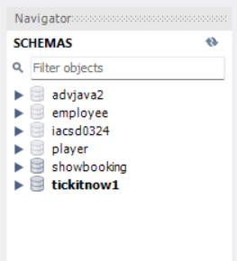

**Tables:**

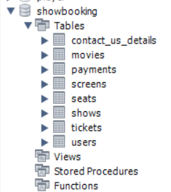

**Contact_us_details:**

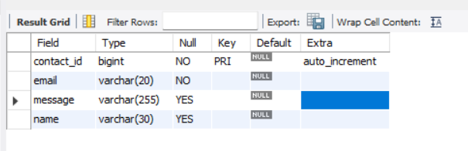

**Movies:**

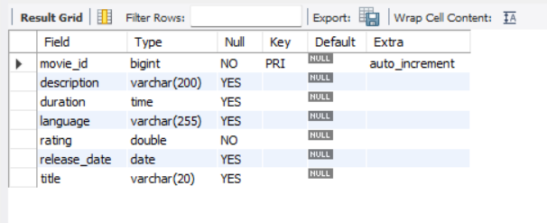

**Payments:**

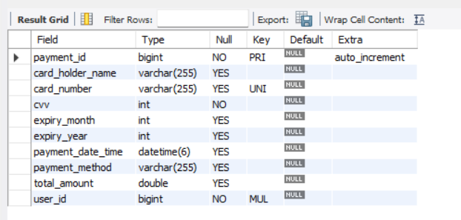

**Screens:**

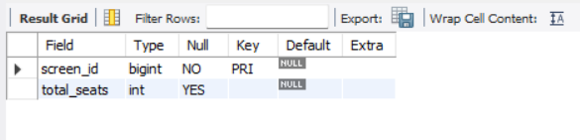

**Shows:**

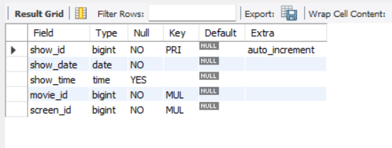

**Tickets:**

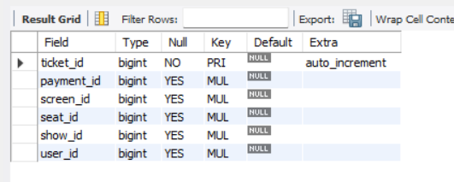

**Users:**

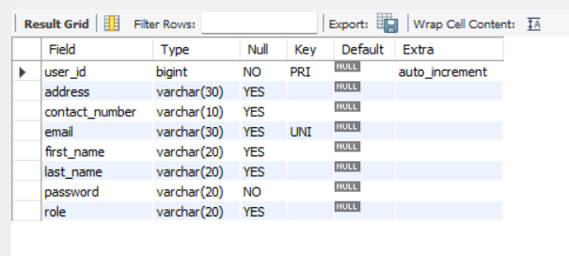

**E-R Diagram:**

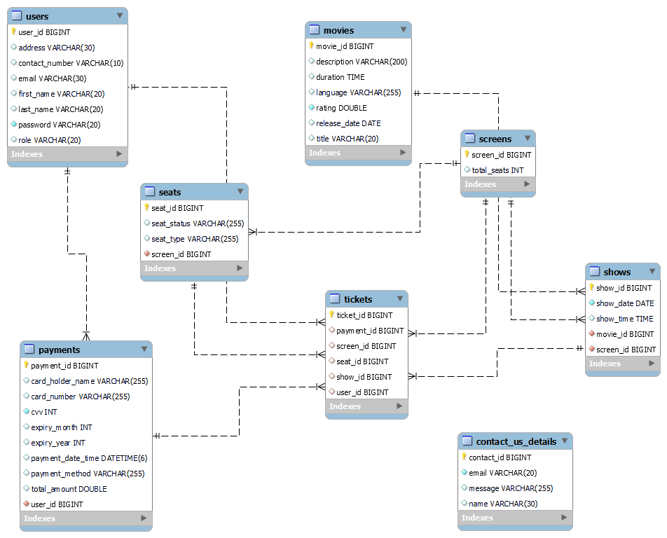

**Manual E-R Diagram:**

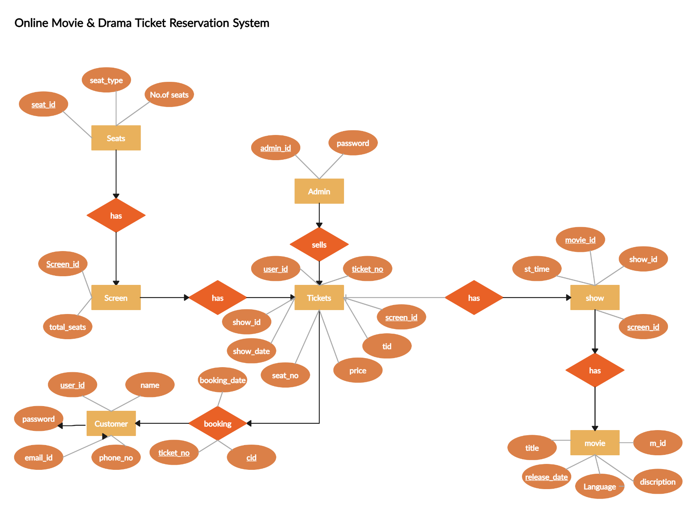

**Use Case Diagram-**

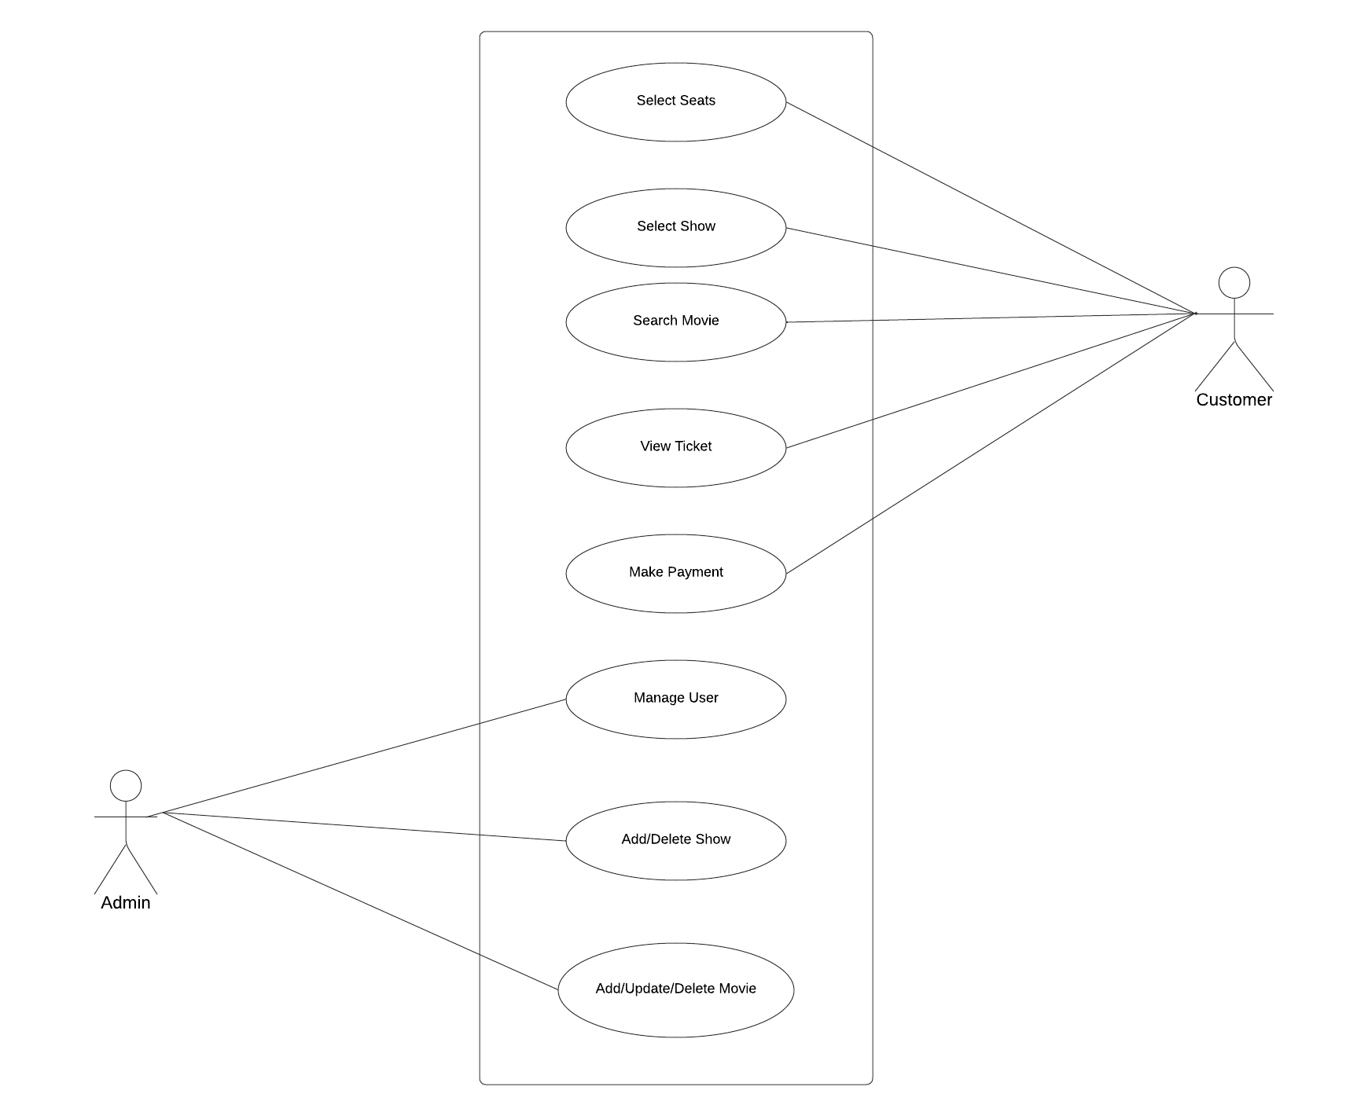

**Data Flow Diagram:**

**0 level:**

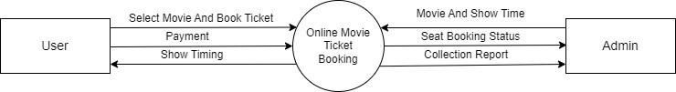

**Level 1**

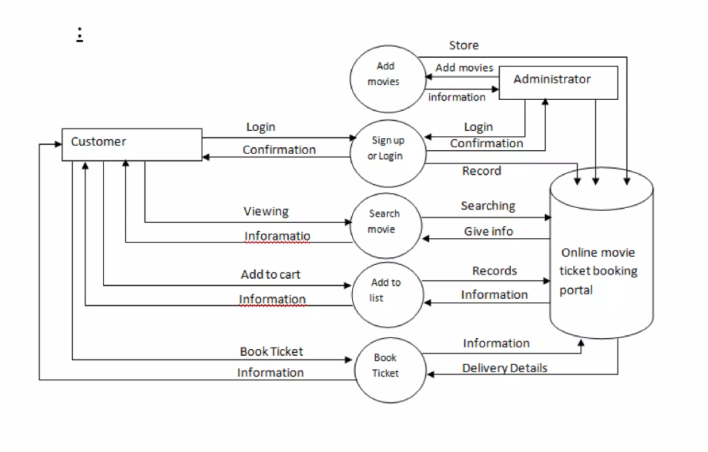

**Activity Diagram:**

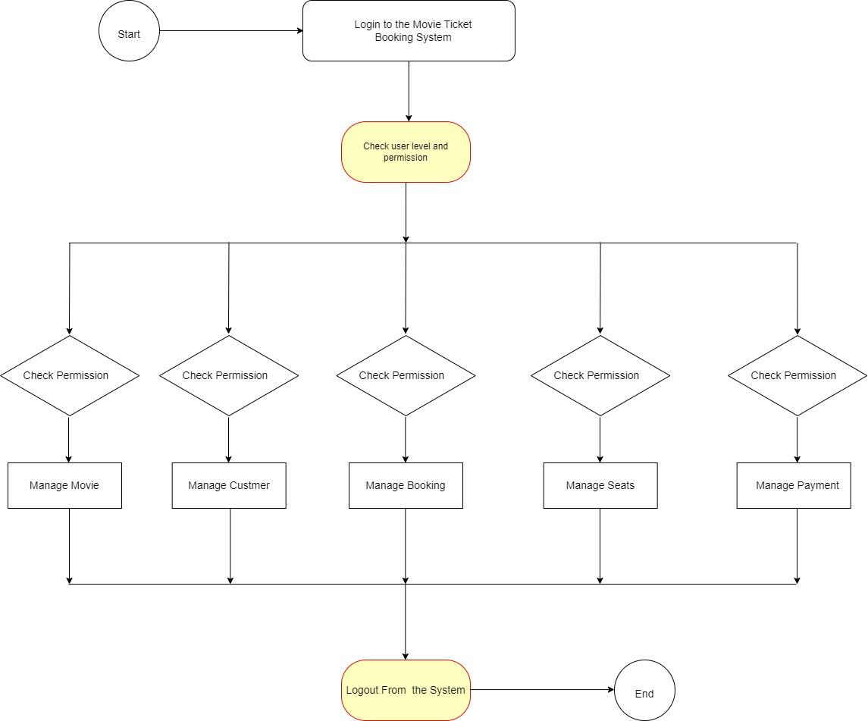

**Class Diagrm**

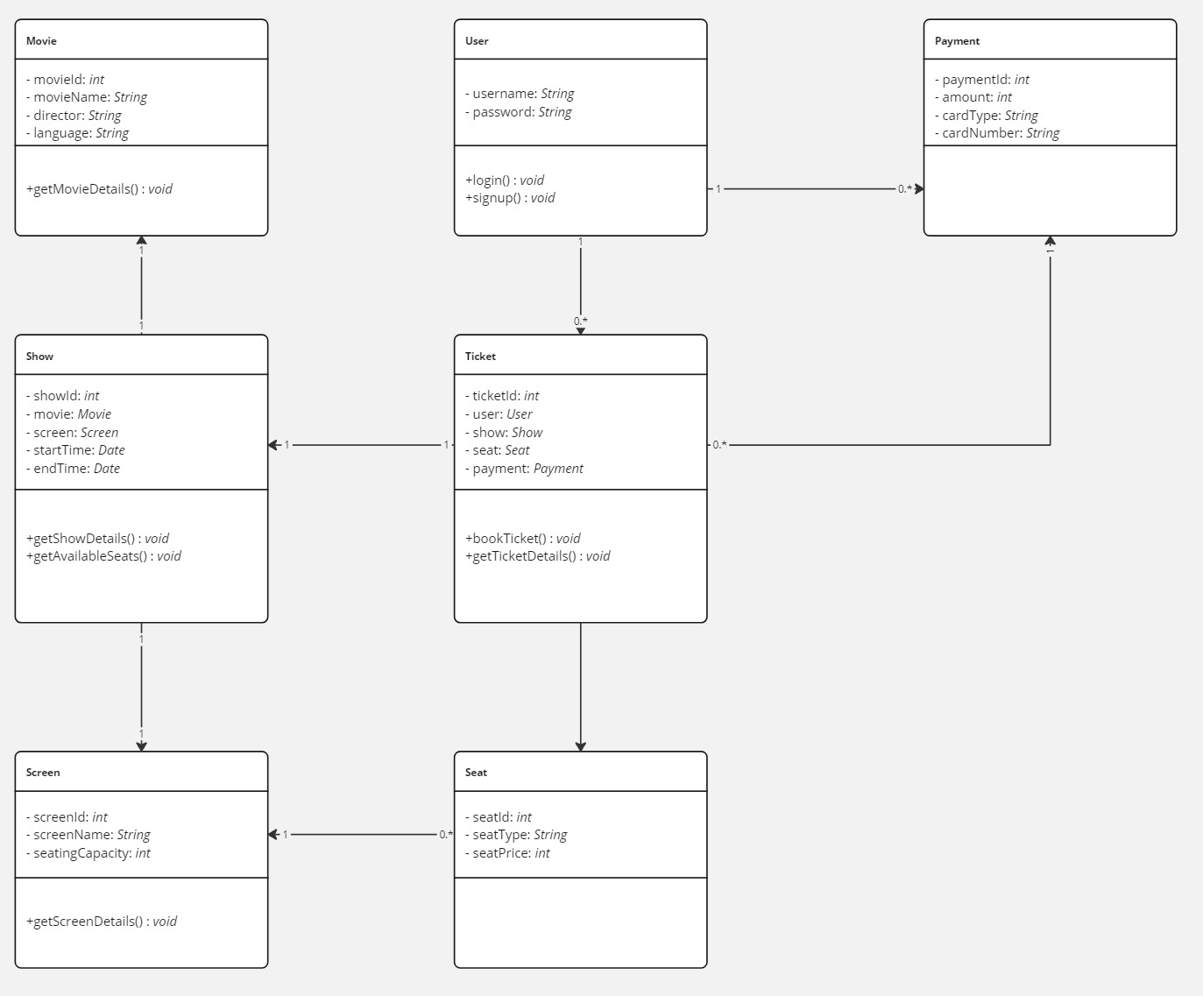

**Sequence Diagram-**

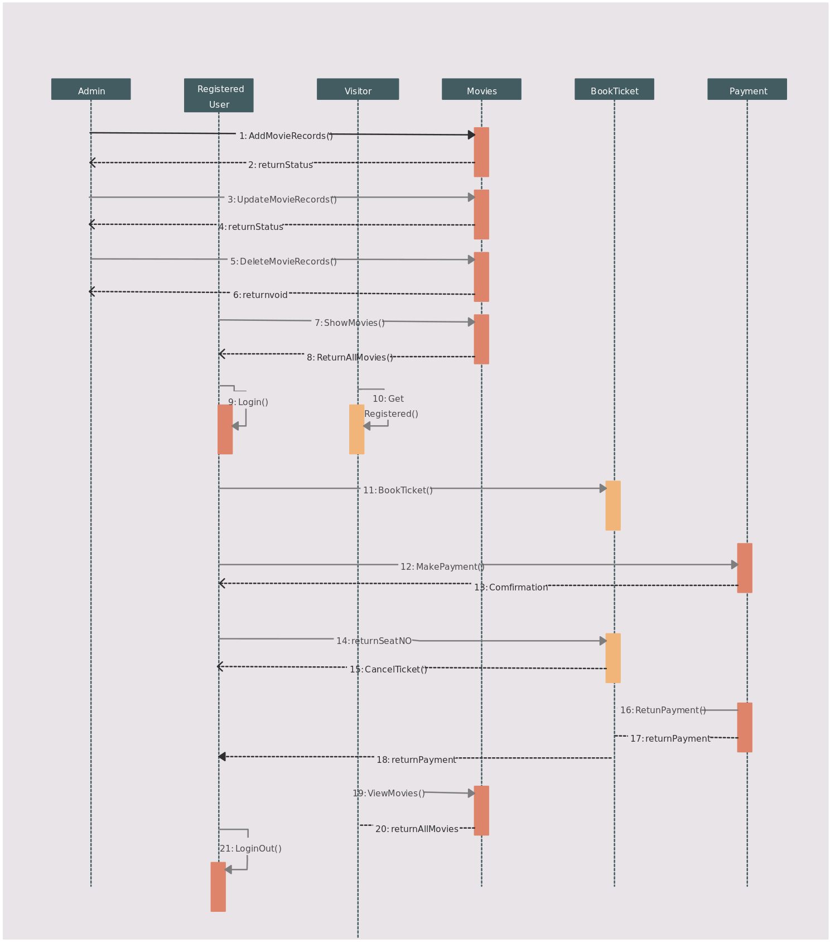

**USER FLOW**

* + - 1. 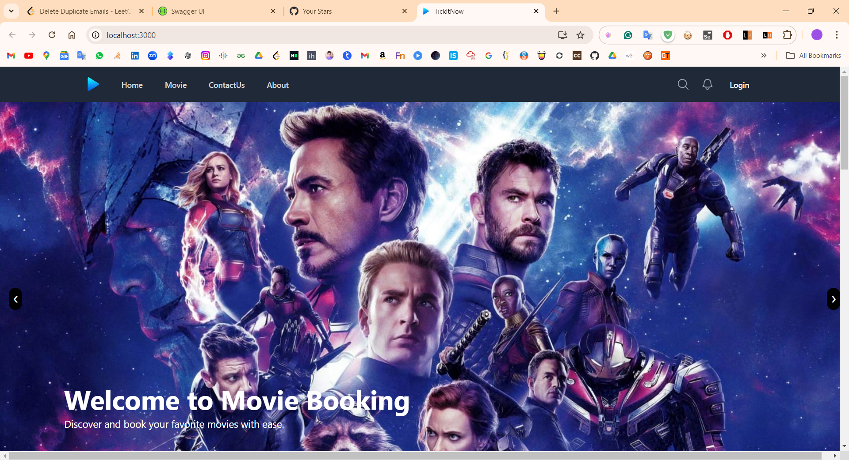Home Page

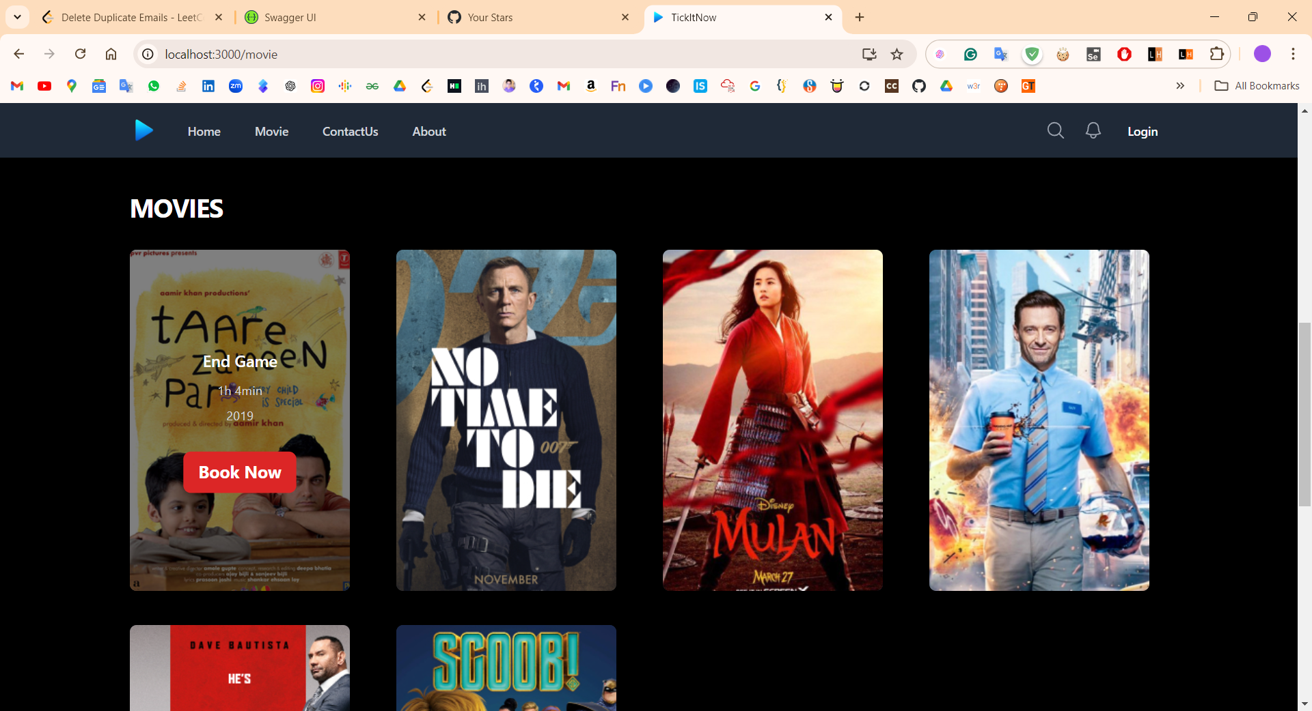

* + - 1. Sign in Page

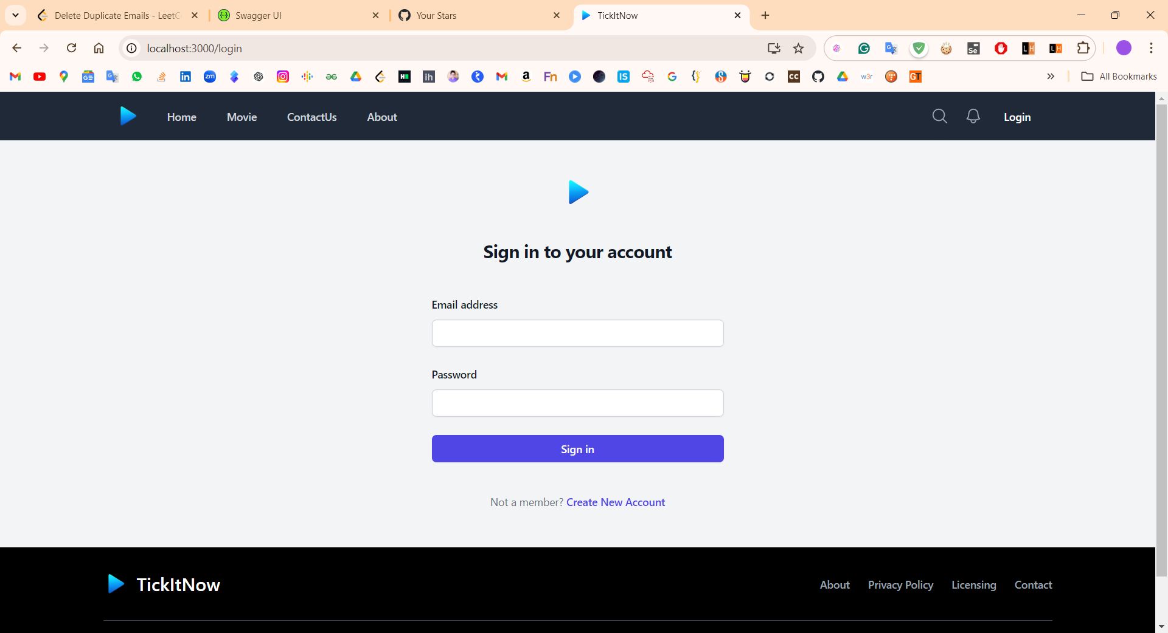

* + - 1. 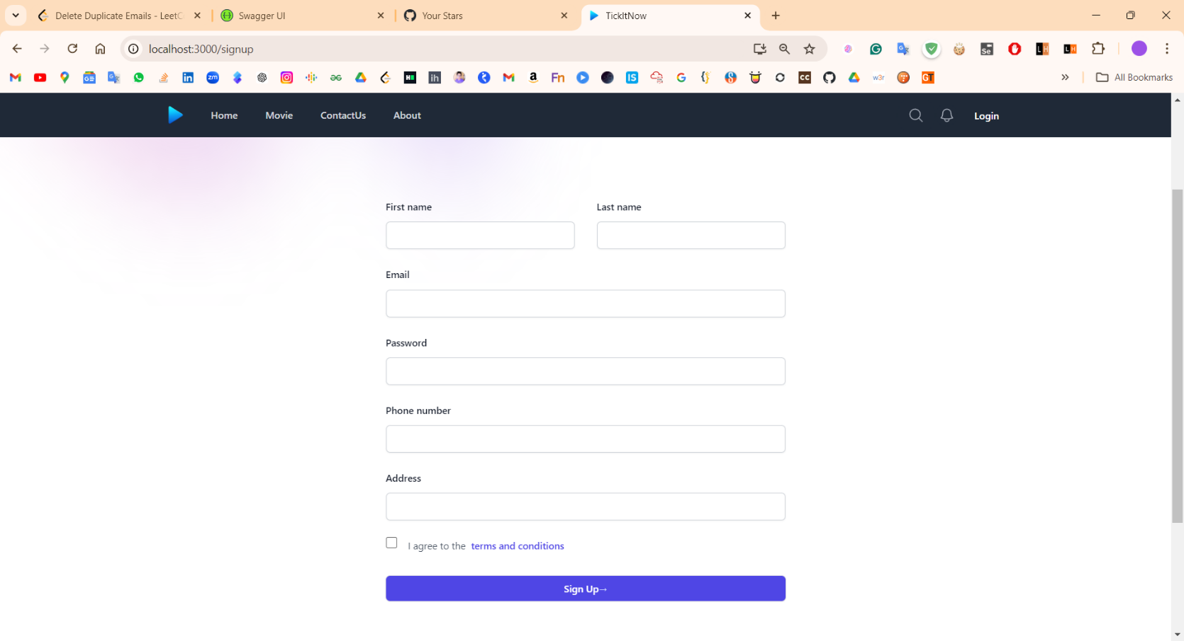Sign Up Page

Search Page 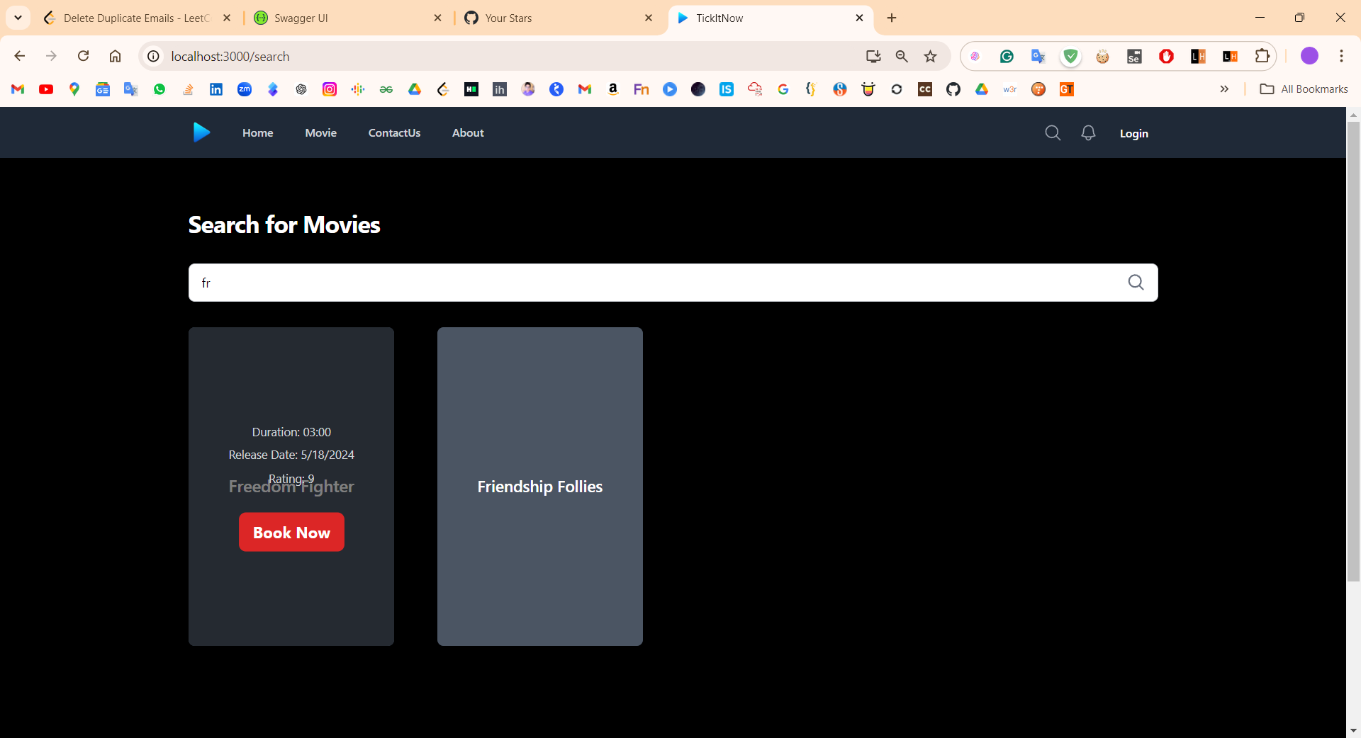

* + - 1. 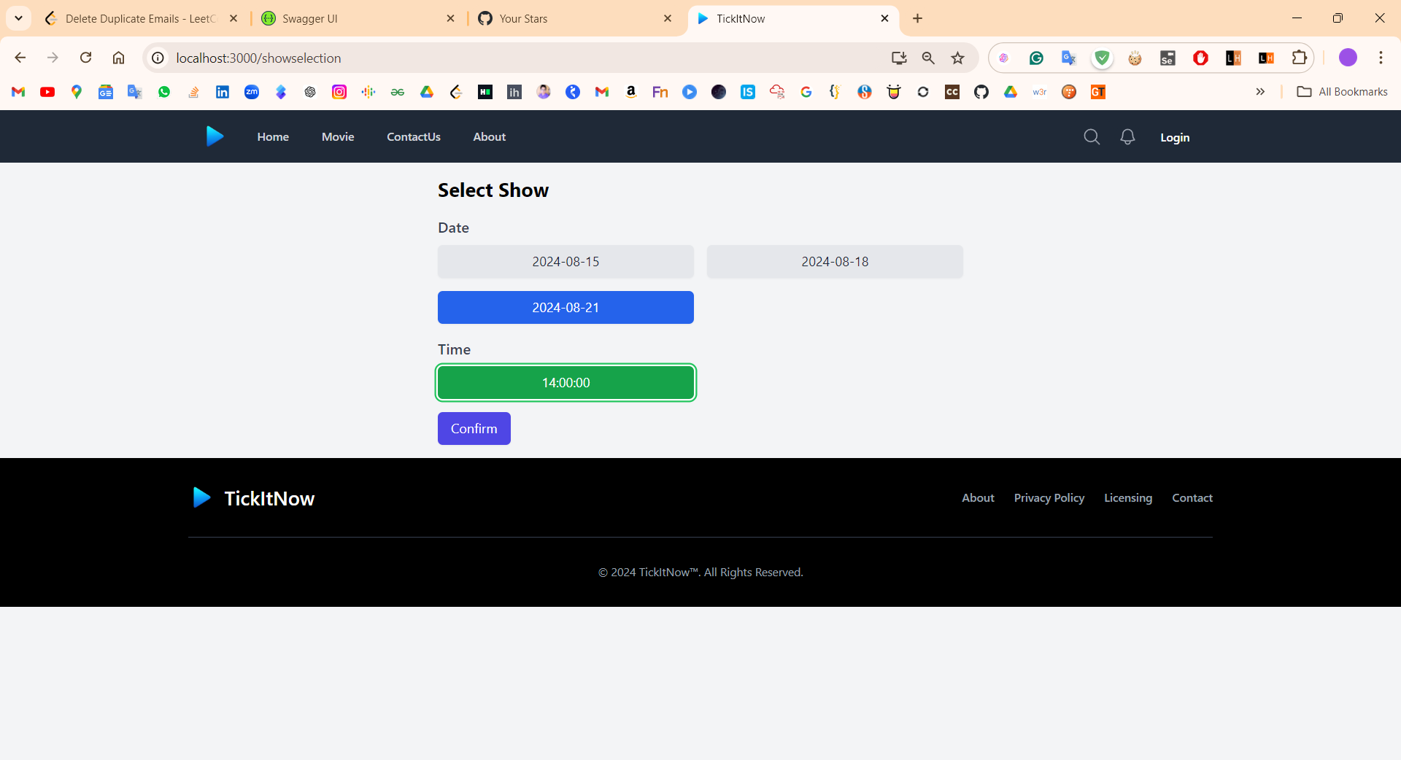Show Page
      2. 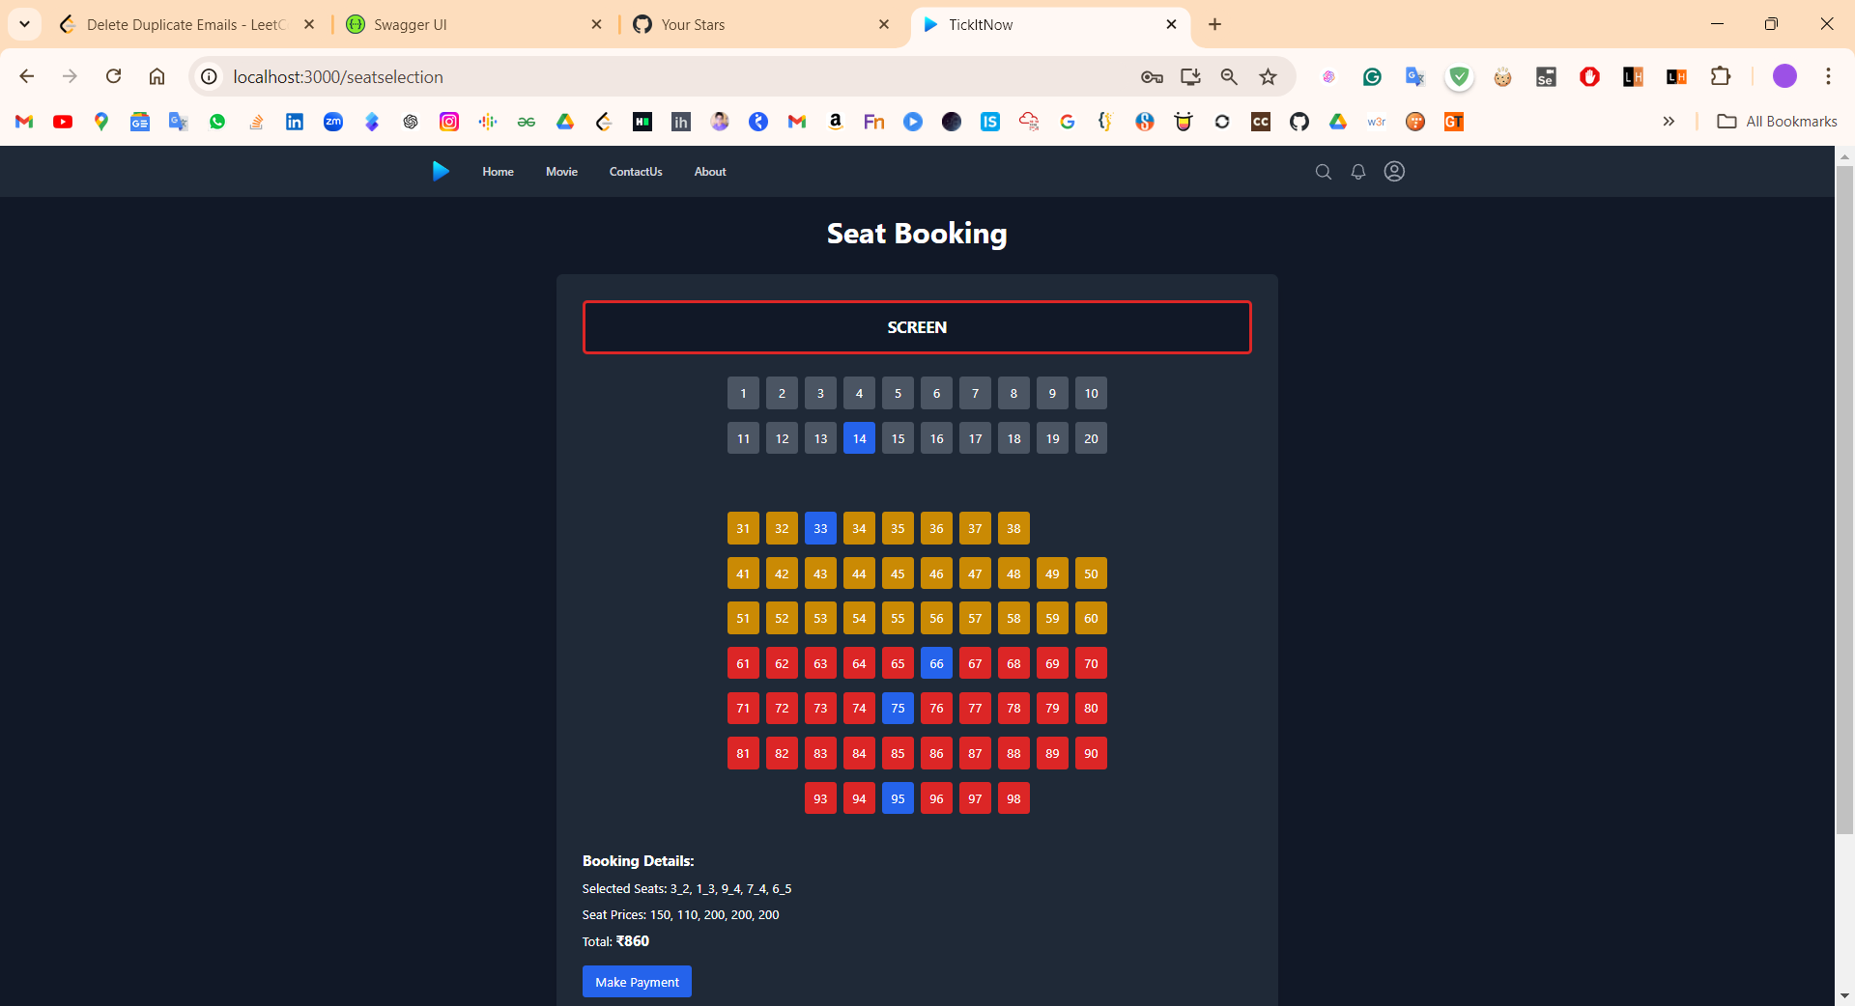Seat List
      3. Payment

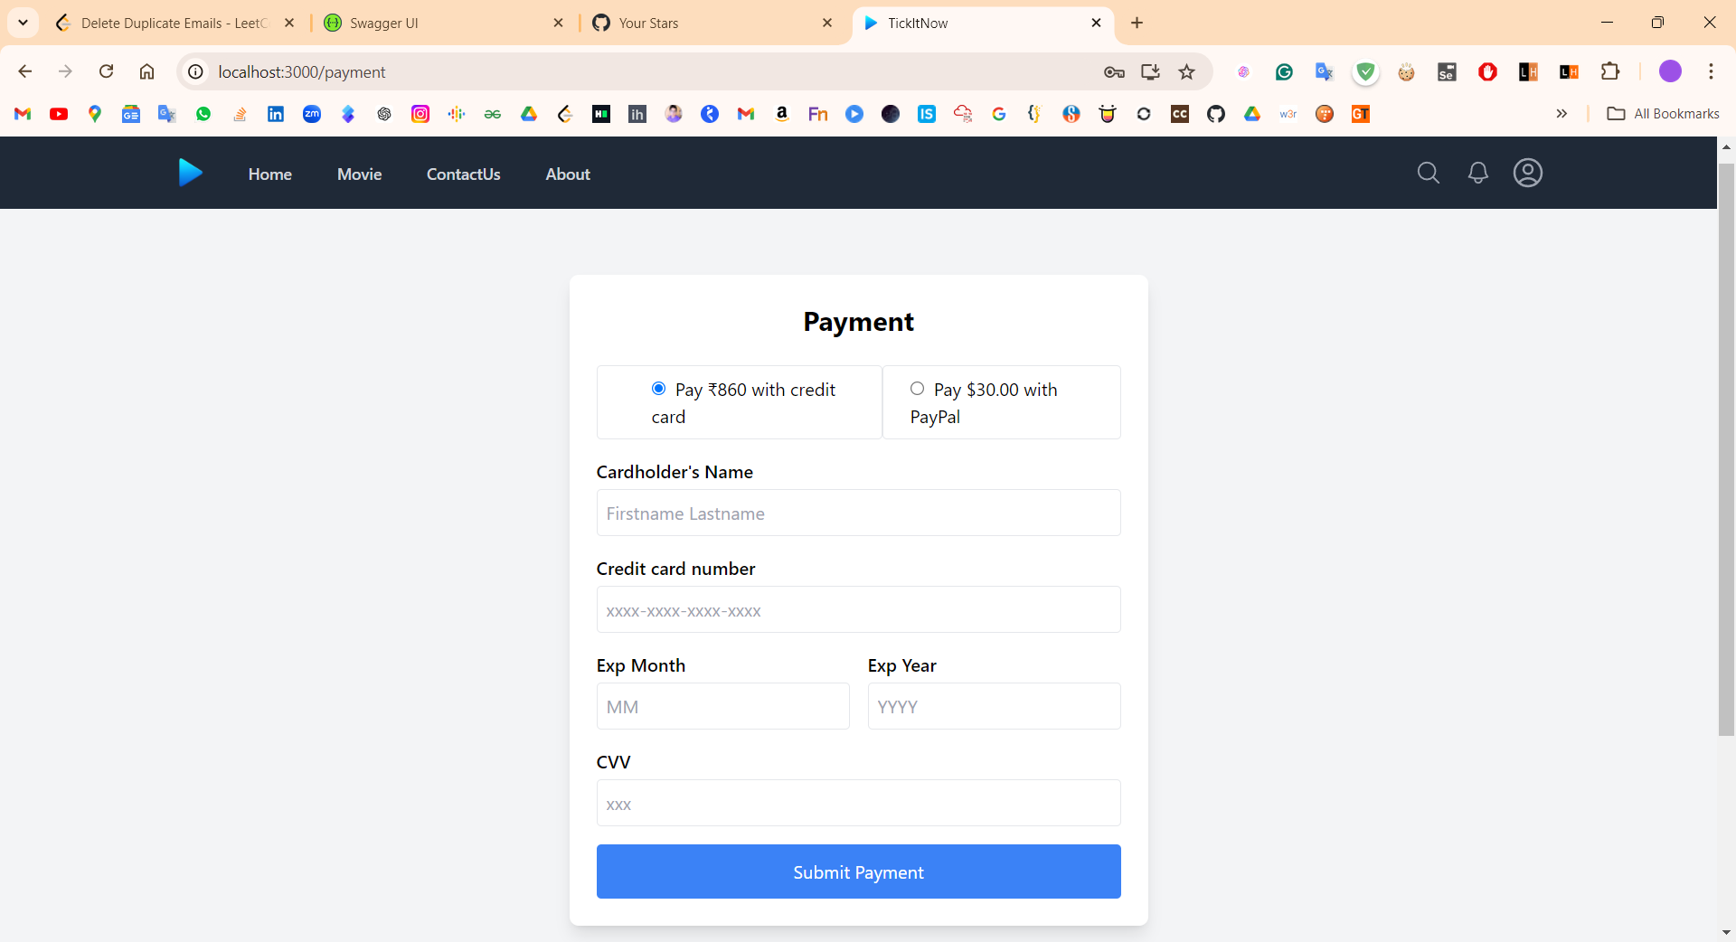

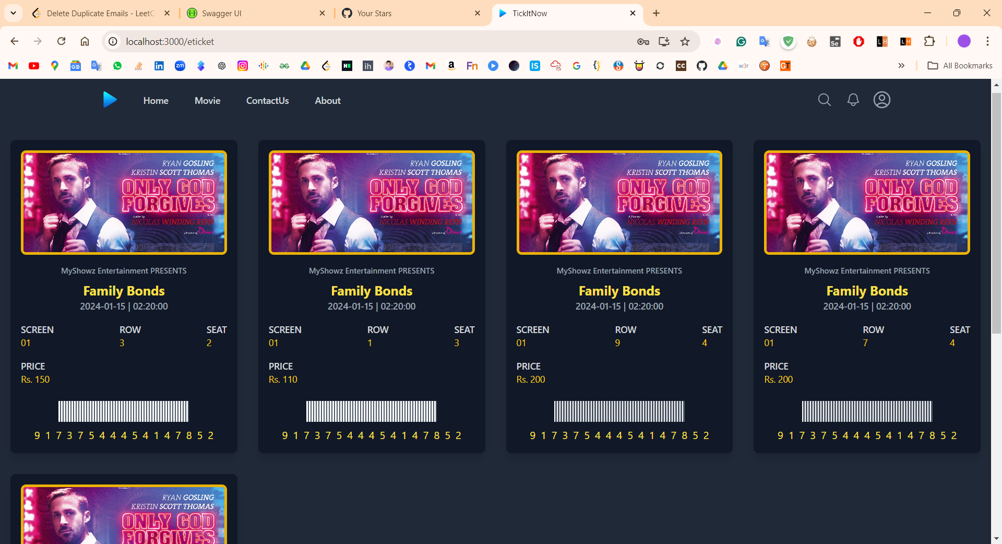 E-Ticket

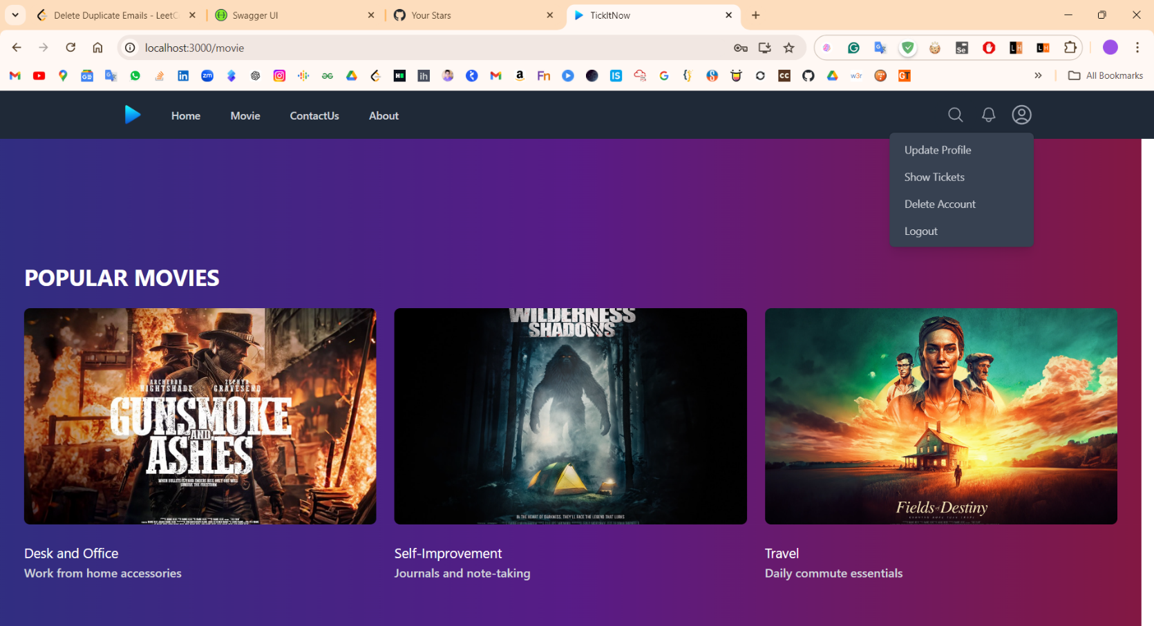 User Actions

Contact us

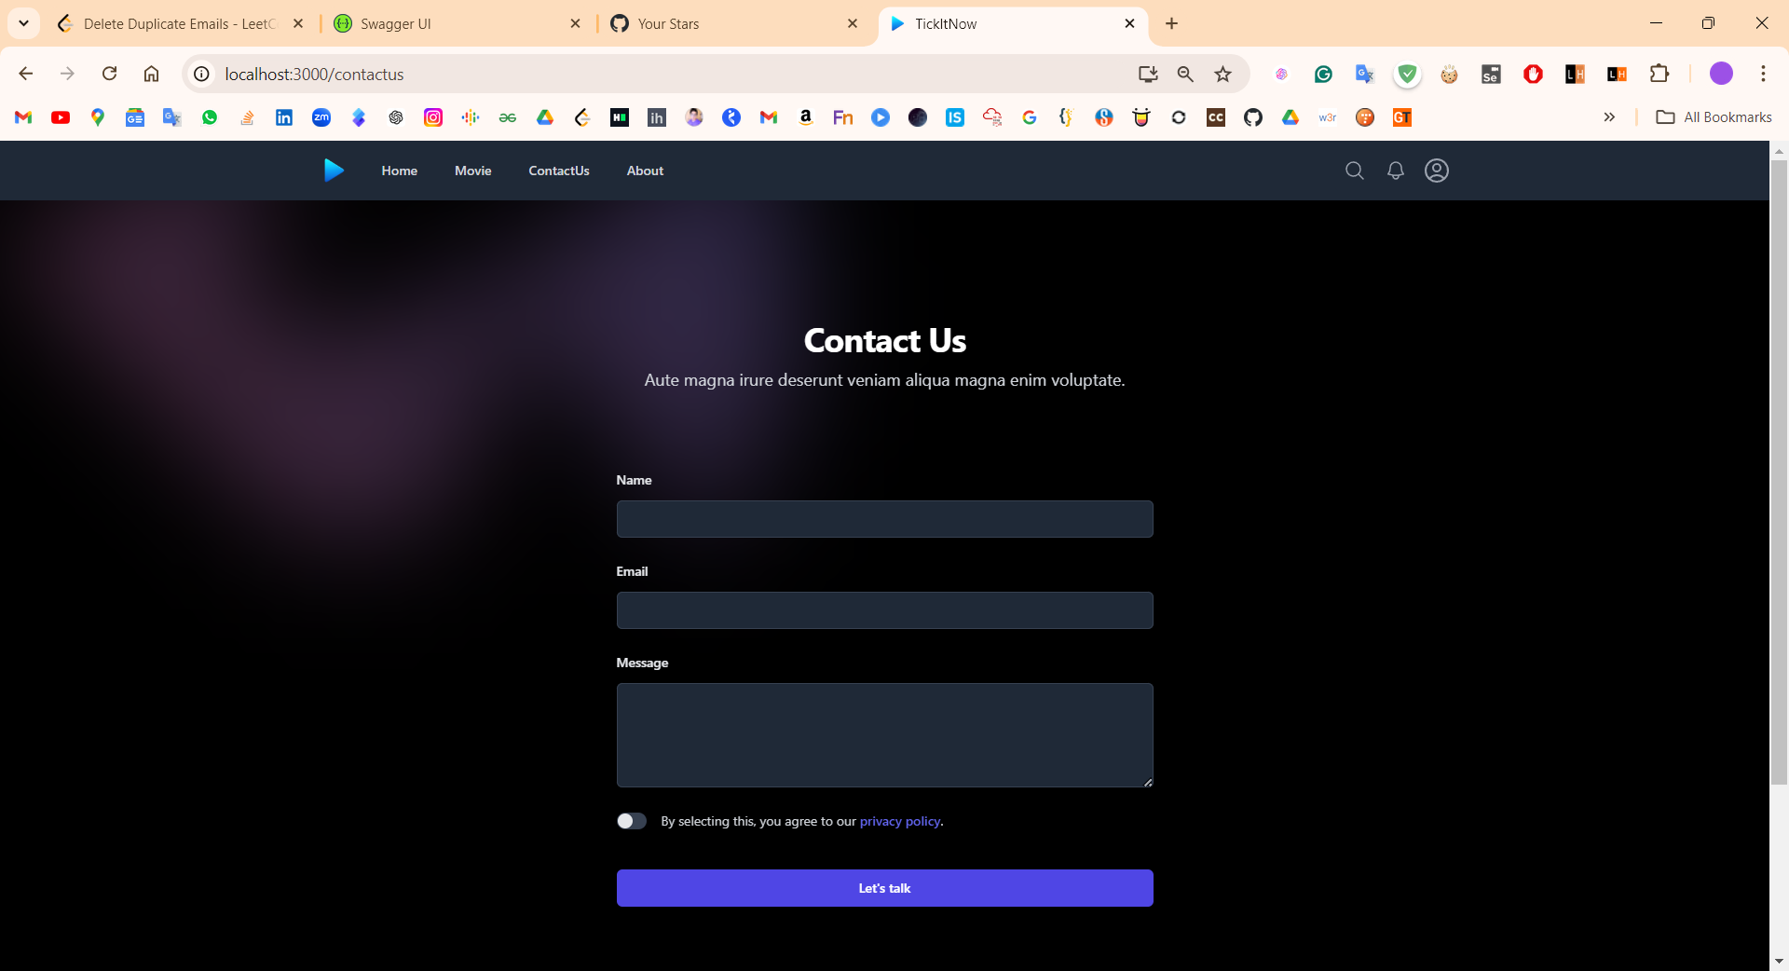

**ADMIN FLOW**

1. Admin Page

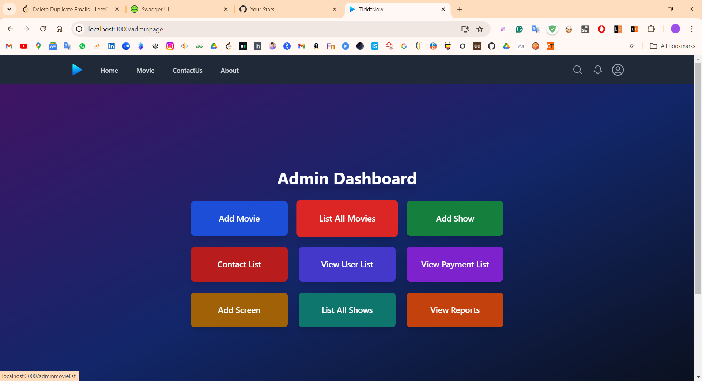

1. Add Movie

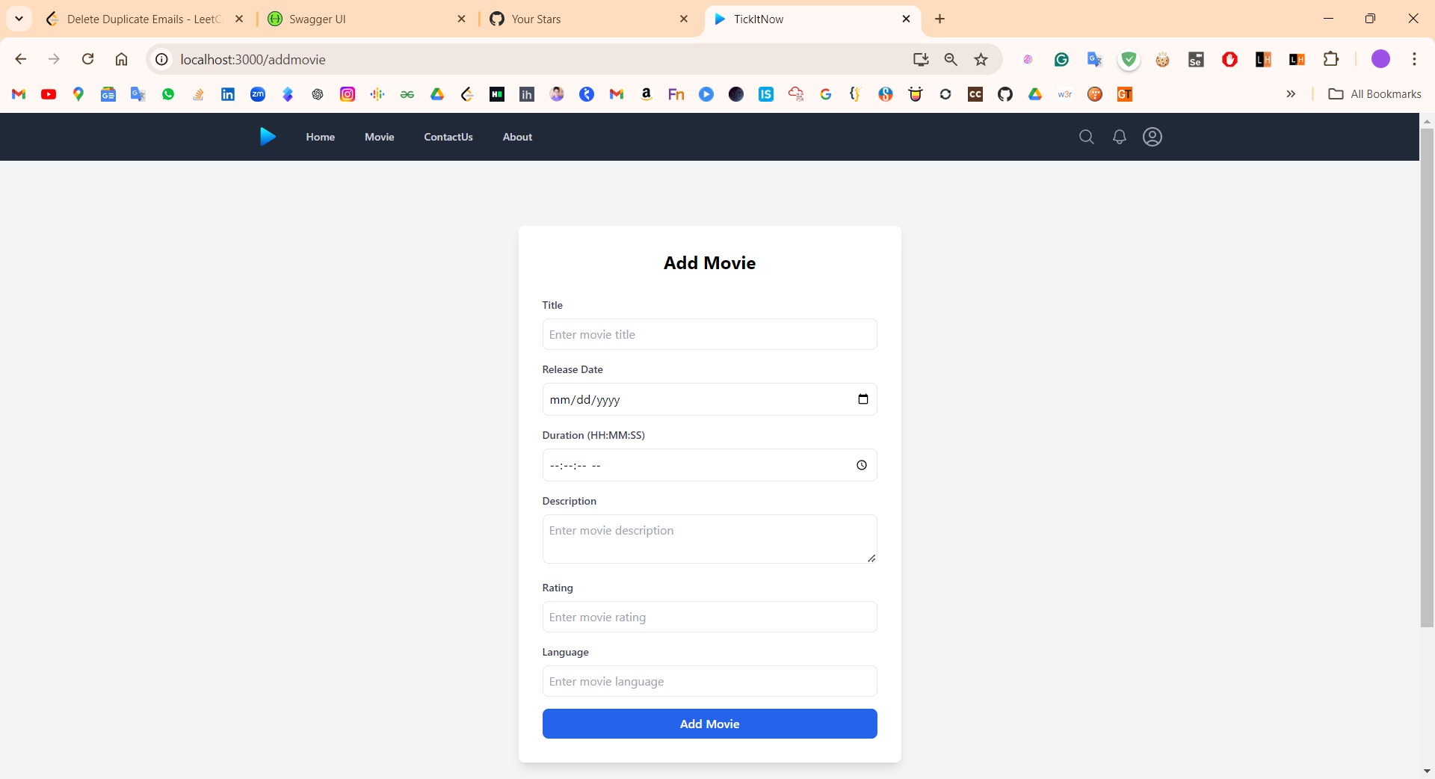

1. Add Show

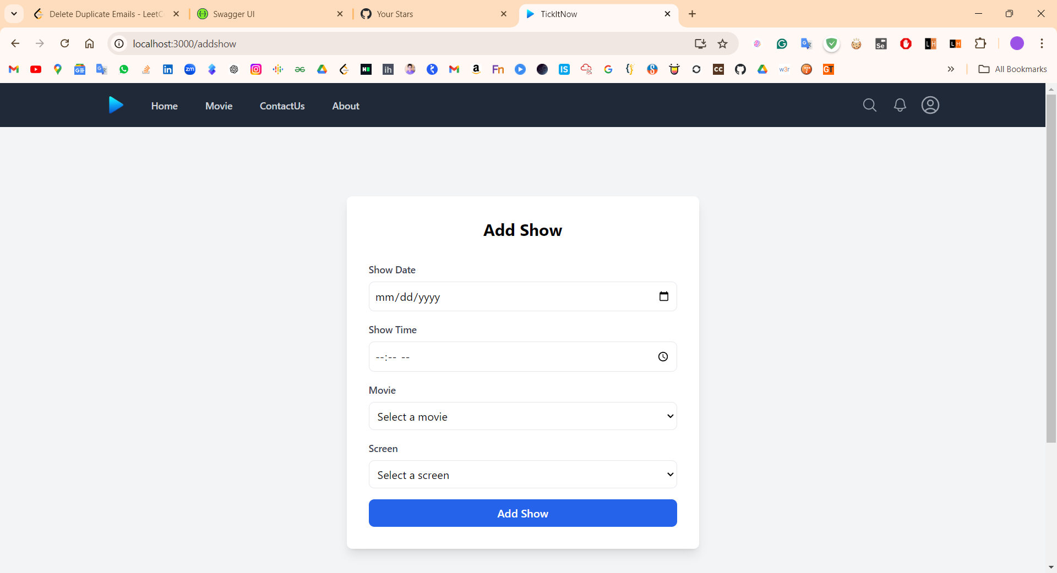

1. 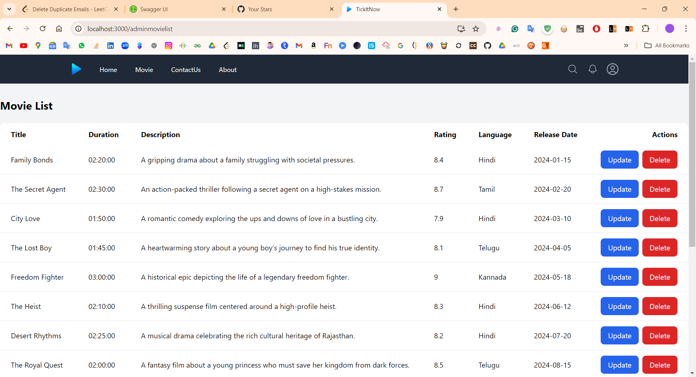Movie List

5

Show List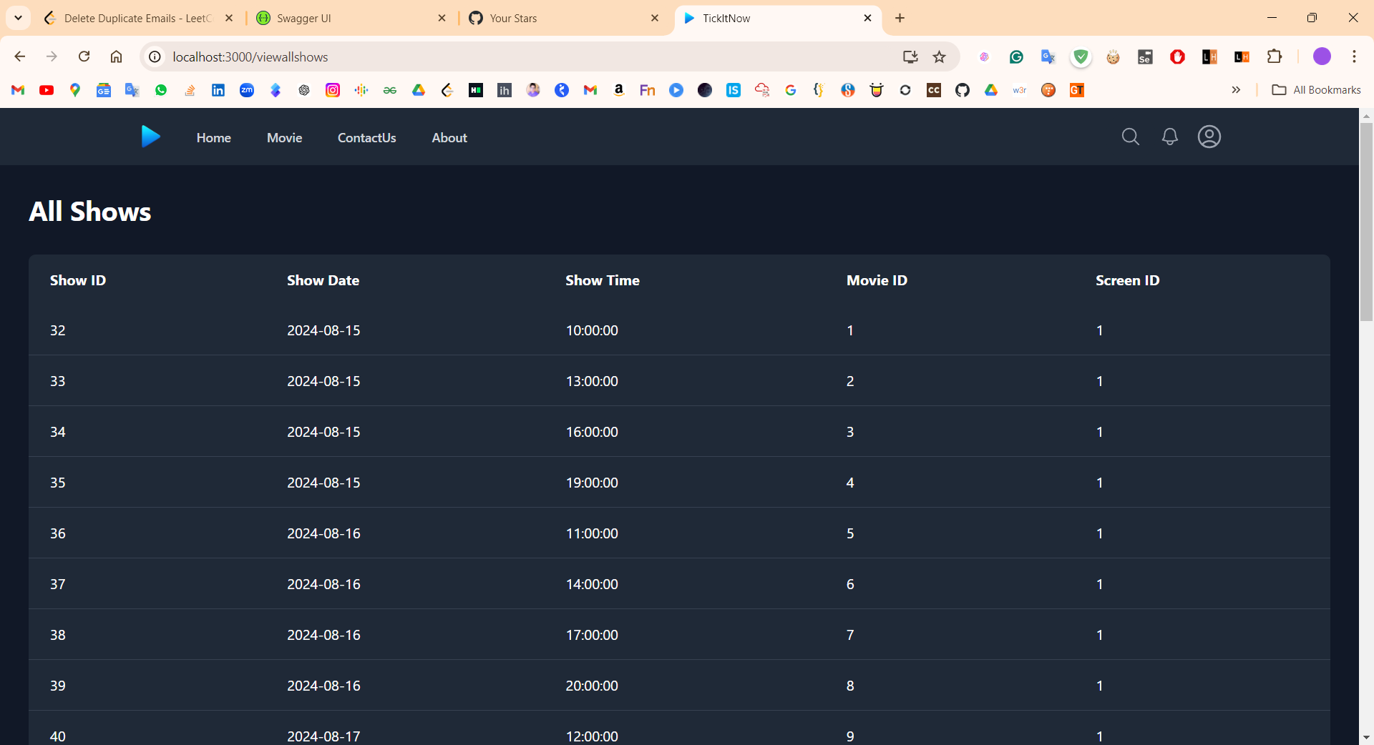

User List

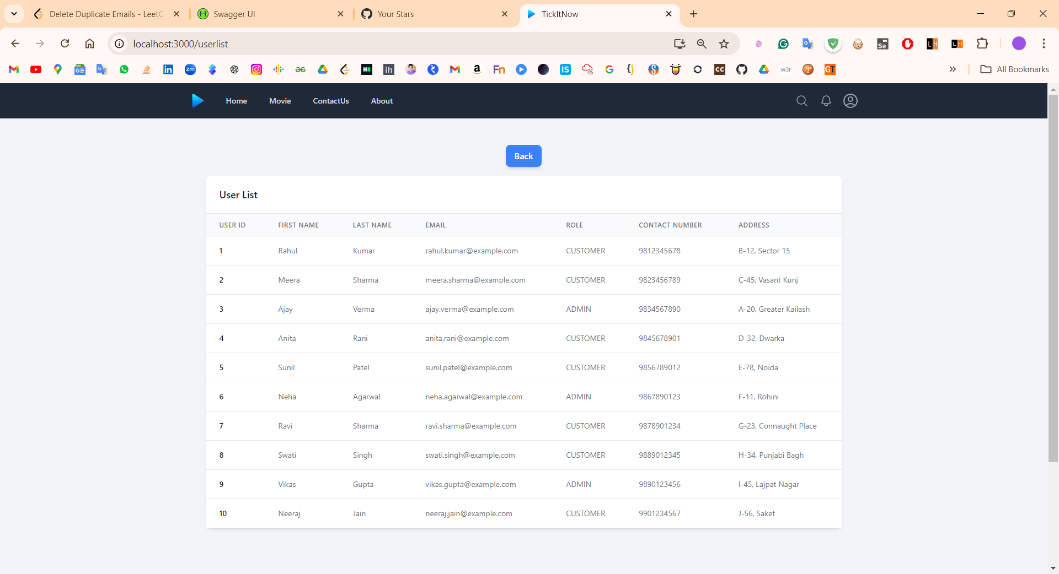

**FUTURE SCOPE**

The Movie Ticket Booking System is designed with scalability and adaptability in mind, ensuring it can evolve alongside technological advancements and user demands. Several potential enhancements can further extend the system’s functionality and user experience:

1. **Mobile Application Development**:
   * **Dedicated Mobile App**: Expanding the platform to include a mobile application for iOS and Android will offer users a more convenient way to book tickets on the go, with features tailored to mobile interfaces.
2. **AI-Driven Recommendations**:
   * **Personalized Suggestions**: Implementing AI algorithms to analyze user preferences and behaviors can provide personalized movie recommendations, enhancing user engagement and satisfaction.
3. **Social Media Integration**:
   * **Social Sharing and Login**: Integrating social media platforms for seamless login, sharing of booked shows, and promotional activities can increase user interaction and broaden the platform’s reach.
4. **Loyalty and Rewards Program**:
   * **Customer Retention**: Introducing a loyalty program that rewards frequent users with discounts, exclusive offers, or early access to bookings can boost customer retention and satisfaction.
5. **Enhanced Security Features**:
   * **Two-Factor Authentication**: Implementing additional security measures such as two-factor authentication will enhance user trust by providing an extra layer of protection during transactions.
6. **Multi-language and Multi-currency Support**:
   * **Global Expansion**: Adding support for multiple languages and currencies can open up the platform to international markets, accommodating diverse user bases and expanding the system’s reach.
7. **Advanced Analytics Dashboard**:
   * **Data Insights**: Developing a more comprehensive analytics dashboard for admins can offer deeper insights into user behavior, sales trends, and operational efficiency, aiding in better decision-making.
8. **Integration with Third-Party Services**:
   * **Partnerships**: Partnering with food delivery services, ride-sharing apps, or merchandise stores can provide users with a one-stop solution for their entire movie experience.

**CONCLUSION**

The Movie Ticket Booking System project stands as a remarkable intersection of technology and entertainment, reimagining the traditional movie ticket booking process for the digital age. Through a meticulous blend of innovative features, streamlined processes, and user-centric design, the system has redefined how audiences’ access and enjoy cinematic experiences while optimizing theater management.

The project's objectives of simplifying ticket booking, automating theater operations, enhancing user experiences, and improving resource allocation have been successfully realized. Users now benefit from real-time movie listings, interactive seat selection, and secure online payments, ensuring a seamless and convenient booking journey. Theater administrators, on the other hand, enjoy an efficient admin dashboard that empowers them to manage schedules, seats, and bookings with precision.

The robust backend, built using the Spring Boot framework, serves as the backbone of the system, ensuring secure data management, responsive communication, and streamlined processes. This technology foundation not only guarantees a smooth user experience but also paves the way for future enhancements and scalability.

Looking ahead, the system's potential for growth remains promising. The envisioned development of a dedicated mobile app, AI-driven recommendations, and integration with social media platforms promises to elevate user engagement and reach. These possibilities underscore the system's adaptability and readiness to embrace emerging trends.

In essence, the Movie Ticket Booking System project embodies the evolution of technology's role in shaping traditional industries. By offering an intuitive, efficient, and convenient movie ticket booking experience, the system bridges the gap between entertainment and innovation, leaving an indelible mark on how audiences and theaters interact in the digital era.

**REFERENCES**

References: https://bootstrapmade.com/mentor-free-education-bootstrap-theme/ <https://www.javatpoint.com/java-mail-api-tutorial>

https://angular.io/docs <https://javaee.github.io/javaee-spec/javadocs/> https://[www.w3schools.com](http://www.w3schools.com/)

https://www.geeksforgeeks.org/java/?ref=shH